Test Case: tc002_SPX_Dev5_Crear_Requisicion_Spot_Con_FAD_Tipo_Cobro_CC
Step 1 - Enter username and password and click to button Enter : Credentials Entered
Image file-name: QC_Testing-tc002_SPX_Dev5_Crear_Requisicion_Spot_Con_FAD_Tipo_Cobro_CC-1789483406924

Step 2 - Select to UEN and Access to Spot Buy Requisitions : UEN Correctly selected and Correct access
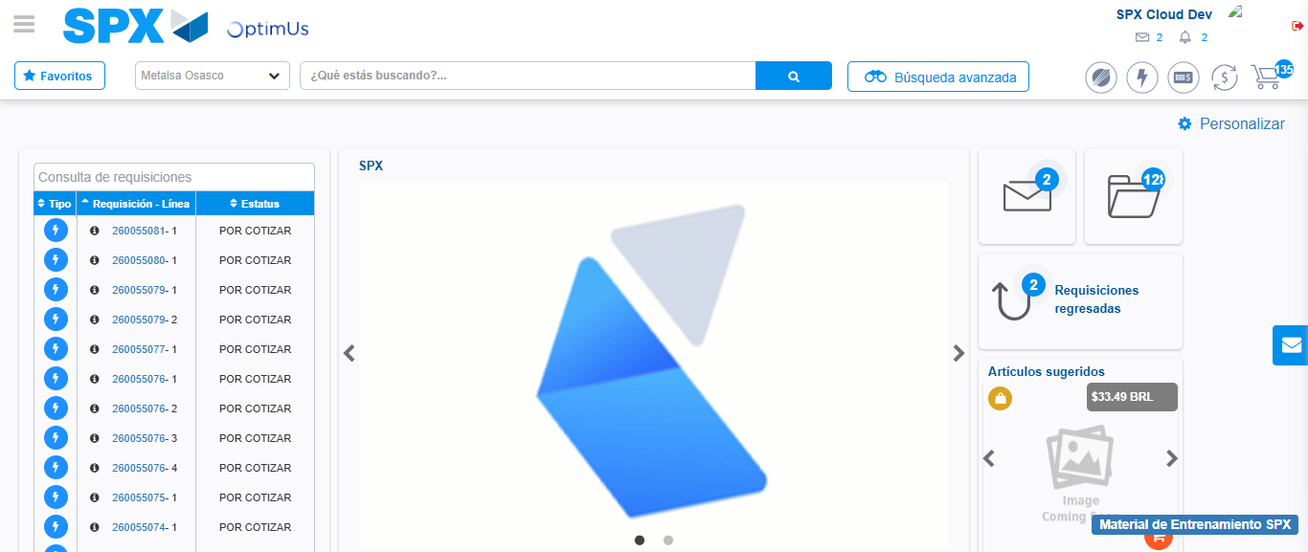Image file-name: QC_Testing-tc002_SPX_Dev5_Crear_Requisicion_Spot_Con_FAD_Tipo_Cobro_CC-1789483440968

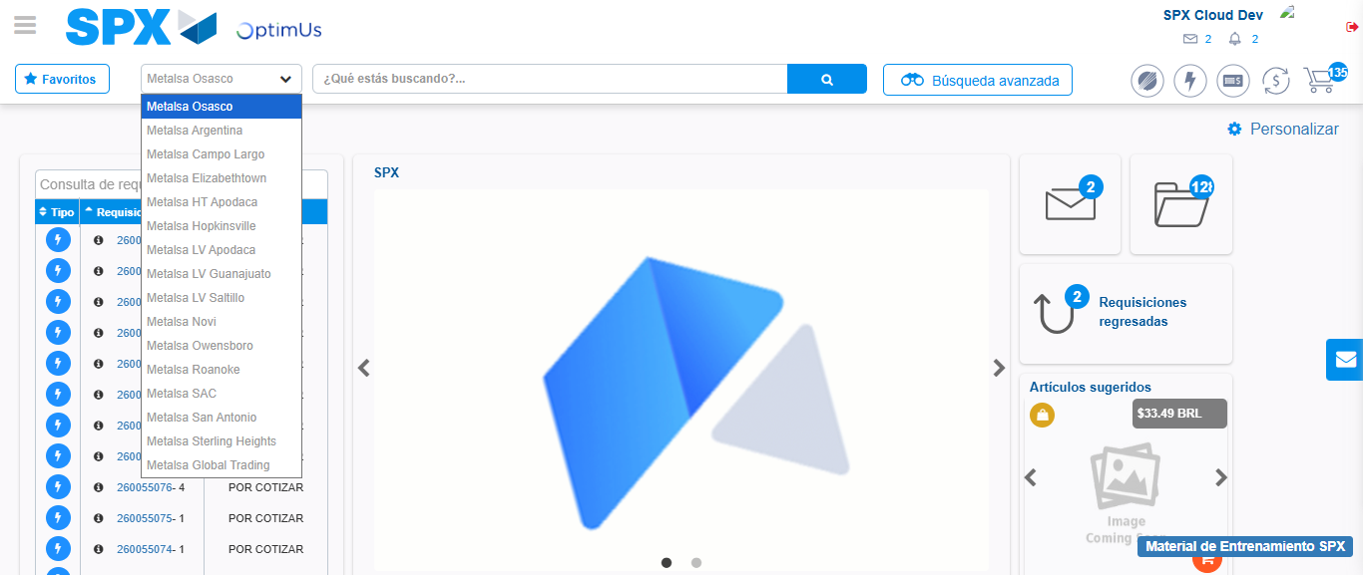Image file-name: QC_Testing-tc002_SPX_Dev5_Crear_Requisicion_Spot_Con_FAD_Tipo_Cobro_CC-1789483441488

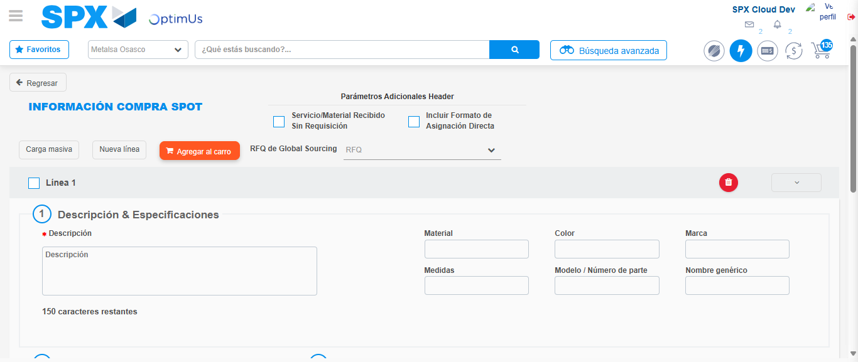Image file-name: QC_Testing-tc002_SPX_Dev5_Crear_Requisicion_Spot_Con_FAD_Tipo_Cobro_CC-1789483445564

Step 3 - Add FAD to Requisition: FAD Successfully Added
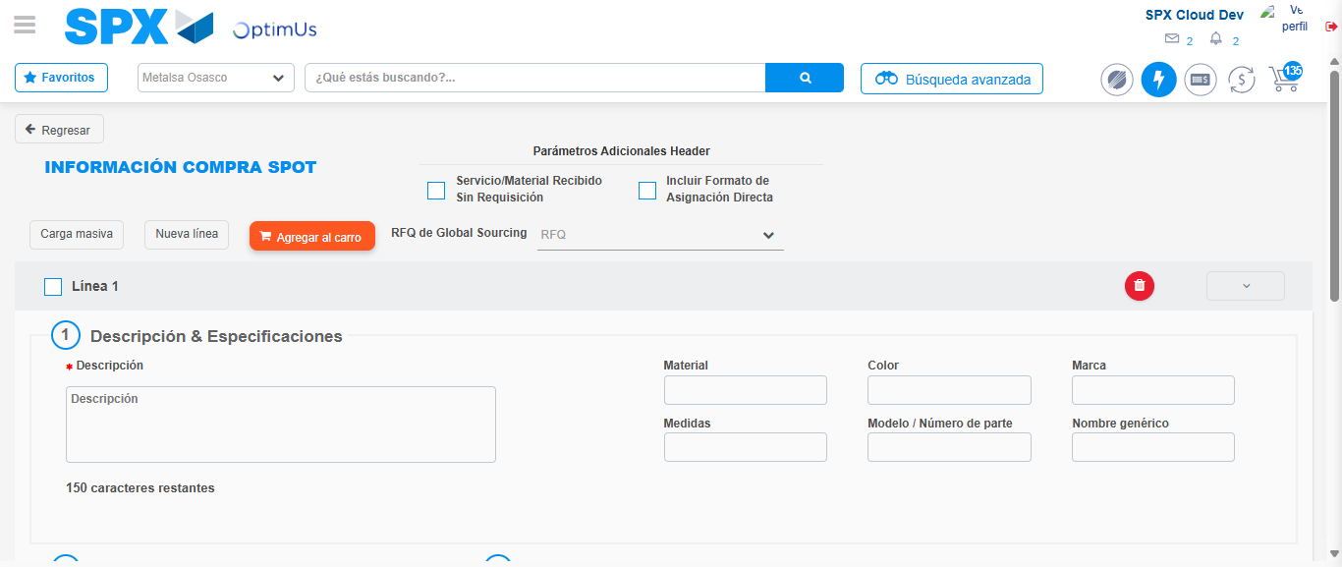Image file-name: QC_Testing-tc002_SPX_Dev5_Crear_Requisicion_Spot_Con_FAD_Tipo_Cobro_CC-1789483445863

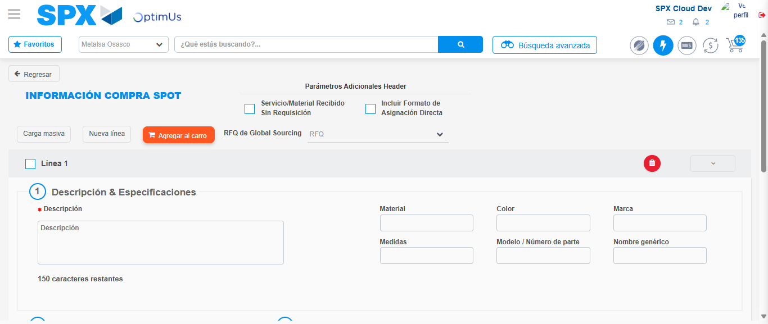Image file-name: QC_Testing-tc002_SPX_Dev5_Crear_Requisicion_Spot_Con_FAD_Tipo_Cobro_CC-1789483446112

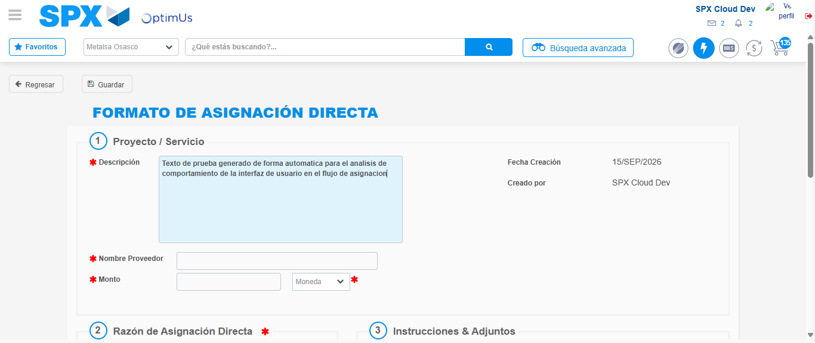Image file-name: QC_Testing-tc002_SPX_Dev5_Crear_Requisicion_Spot_Con_FAD_Tipo_Cobro_CC-1789483448876

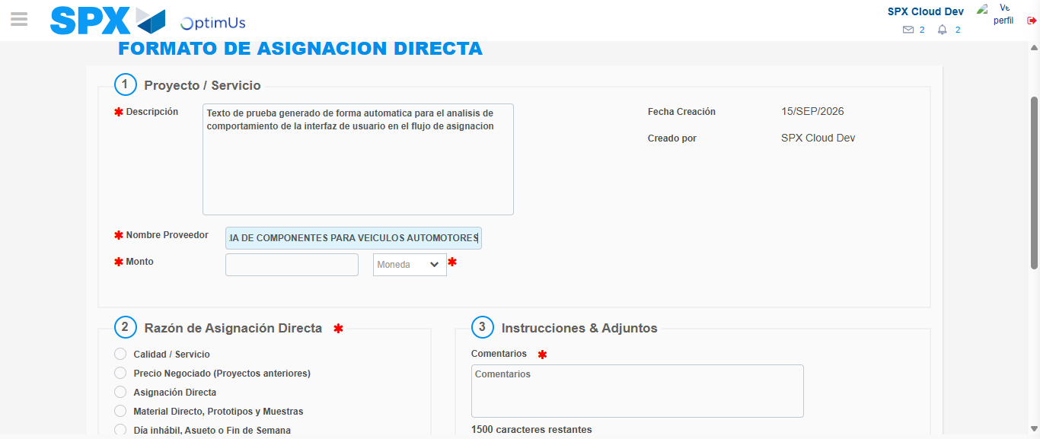Image file-name: QC_Testing-tc002_SPX_Dev5_Crear_Requisicion_Spot_Con_FAD_Tipo_Cobro_CC-1789483457284

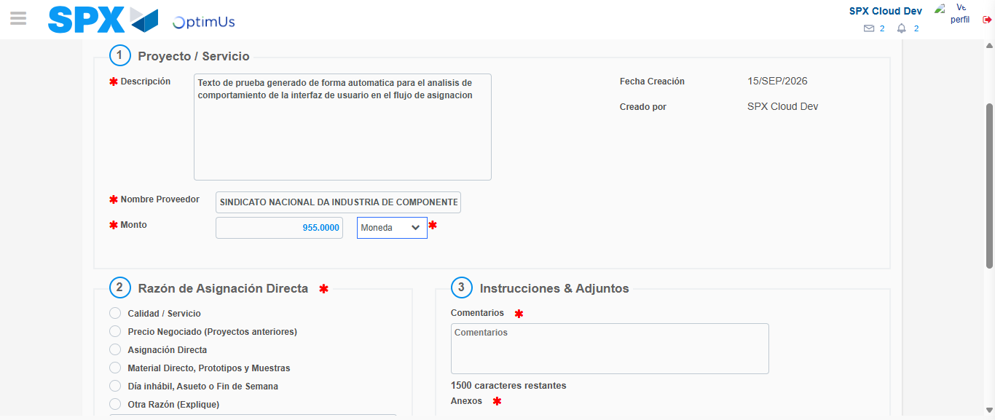Image file-name: QC_Testing-tc002_SPX_Dev5_Crear_Requisicion_Spot_Con_FAD_Tipo_Cobro_CC-1789483457636

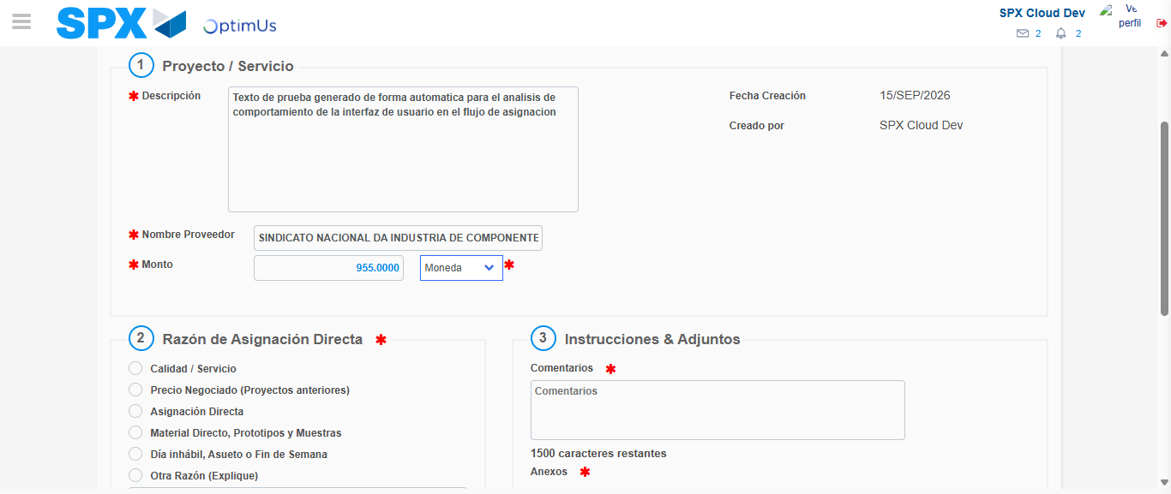Image file-name: QC_Testing-tc002_SPX_Dev5_Crear_Requisicion_Spot_Con_FAD_Tipo_Cobro_CC-1789483457852

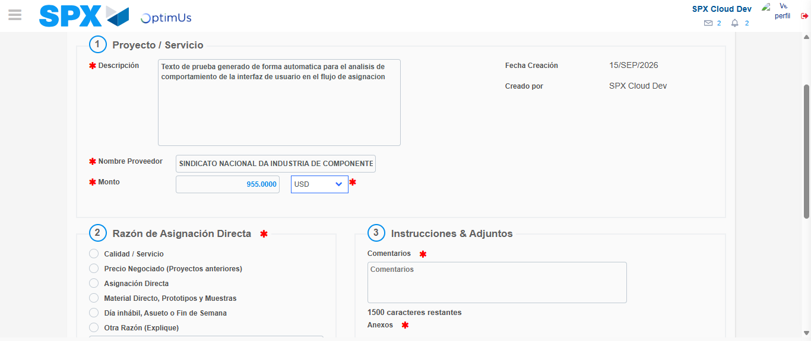Image file-name: QC_Testing-tc002_SPX_Dev5_Crear_Requisicion_Spot_Con_FAD_Tipo_Cobro_CC-1789483458178

Image file-name: QC_Testing-tc002_SPX_Dev5_Crear_Requisicion_Spot_Con_FAD_Tipo_Cobro_CC-1789483458404

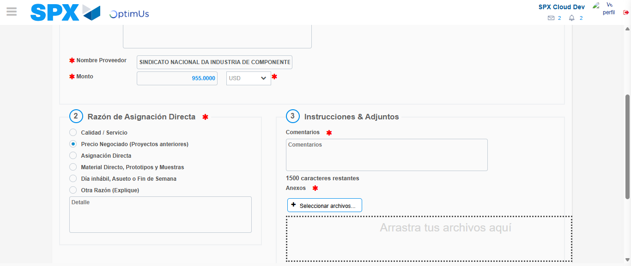Image file-name: QC_Testing-tc002_SPX_Dev5_Crear_Requisicion_Spot_Con_FAD_Tipo_Cobro_CC-1789483459167

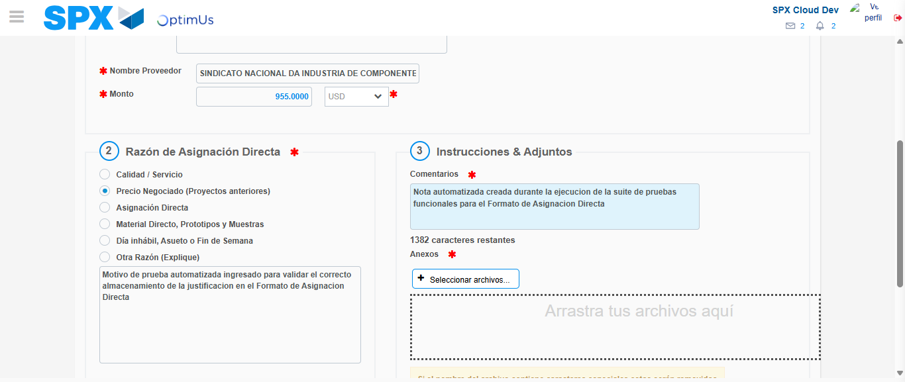Image file-name: QC_Testing-tc002_SPX_Dev5_Crear_Requisicion_Spot_Con_FAD_Tipo_Cobro_CC-1789483470079

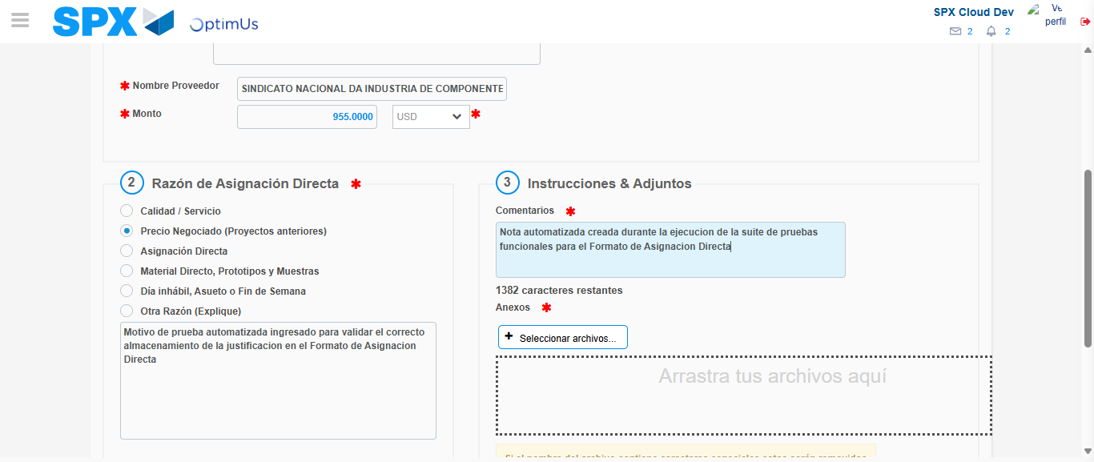Image file-name: QC_Testing-tc002_SPX_Dev5_Crear_Requisicion_Spot_Con_FAD_Tipo_Cobro_CC-1789483470622

Step 4 - Data Capture Spot Buy Requisition: Data captured correctly
Image file-name: QC_Testing-tc002_SPX_Dev5_Crear_Requisicion_Spot_Con_FAD_Tipo_Cobro_CC-1789483445863

Image file-name: QC_Testing-tc002_SPX_Dev5_Crear_Requisicion_Spot_Con_FAD_Tipo_Cobro_CC-1789483446112

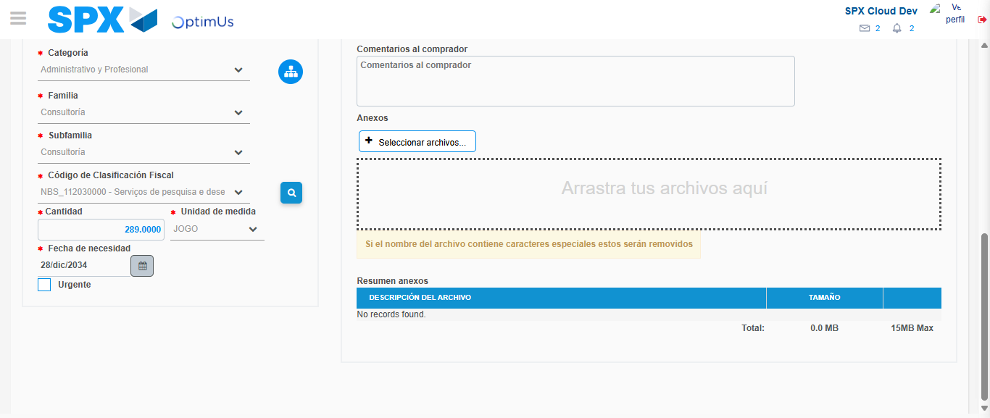Image file-name: QC_Testing-tc002_SPX_Dev5_Crear_Requisicion_Spot_Con_FAD_Tipo_Cobro_CC-1789483486656

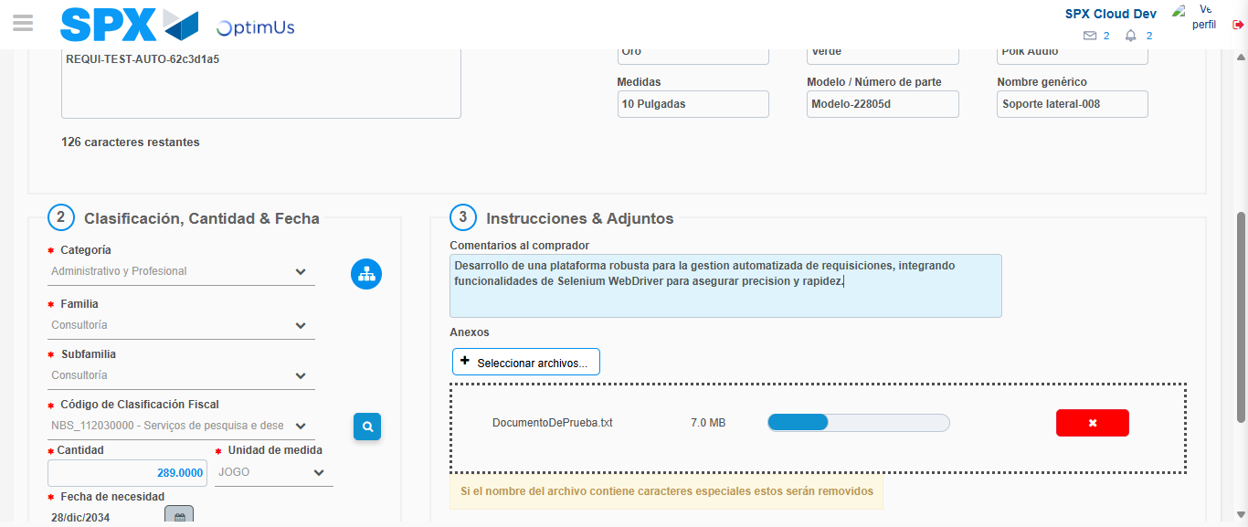Image file-name: QC_Testing-tc002_SPX_Dev5_Crear_Requisicion_Spot_Con_FAD_Tipo_Cobro_CC-1789483487893

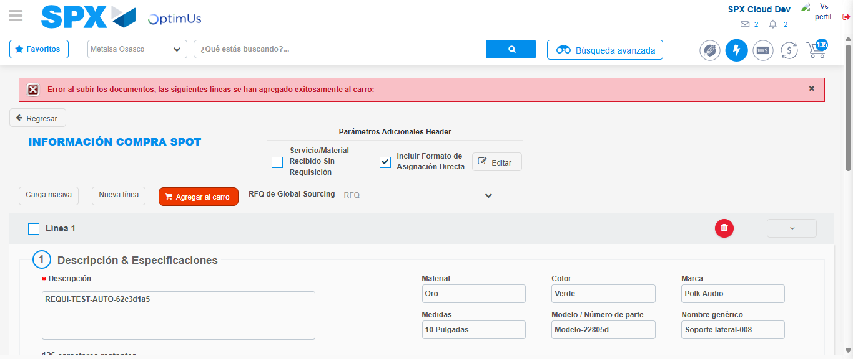Image file-name: QC_Testing-tc002_SPX_Dev5_Crear_Requisicion_Spot_Con_FAD_Tipo_Cobro_CC-1789483500172

Step 8 - Return to Main Page SPX : Return to Main Page SPX
Image file-name: QC_Testing-tc002_SPX_Dev5_Crear_Requisicion_Spot_Con_FAD_Tipo_Cobro_CC-1789483440968

Image file-name: QC_Testing-tc002_SPX_Dev5_Crear_Requisicion_Spot_Con_FAD_Tipo_Cobro_CC-1789483441488

Image file-name: QC_Testing-tc002_SPX_Dev5_Crear_Requisicion_Spot_Con_FAD_Tipo_Cobro_CC-1789483445564

Image file-name: QC_Testing-tc002_SPX_Dev5_Crear_Requisicion_Spot_Con_FAD_Tipo_Cobro_CC-1789483502347

Image file-name: QC_Testing-tc002_SPX_Dev5_Crear_Requisicion_Spot_Con_FAD_Tipo_Cobro_CC-1789483502513

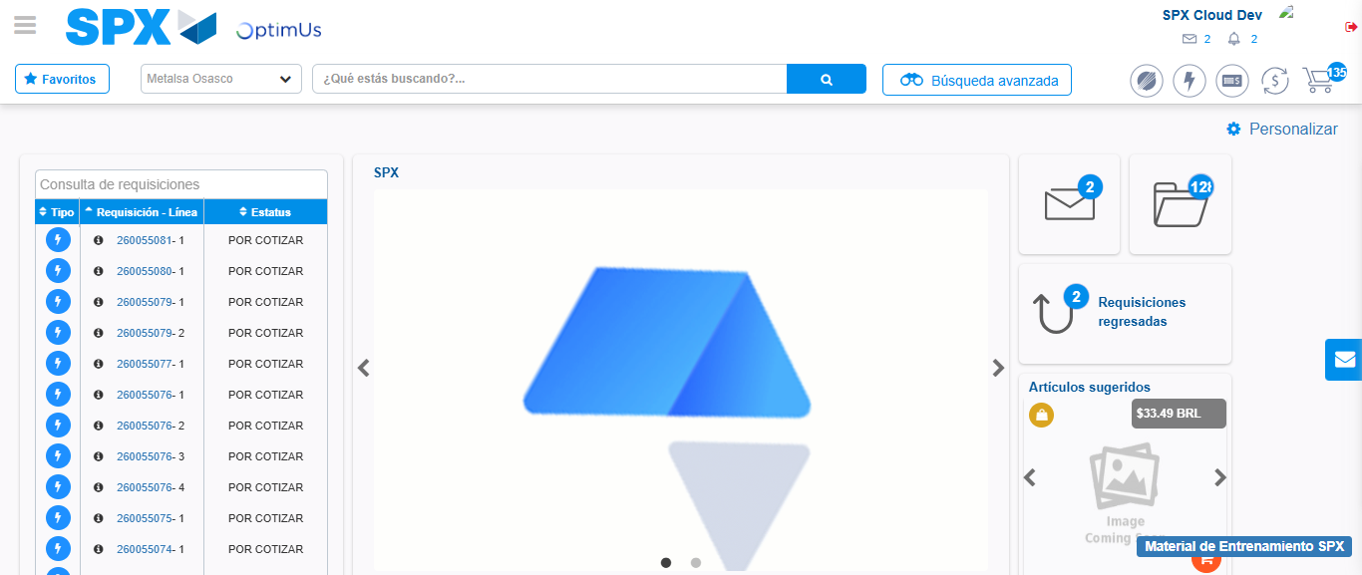Image file-name: QC_Testing-tc002_SPX_Dev5_Crear_Requisicion_Spot_Con_FAD_Tipo_Cobro_CC-1789483523652

Step 9 - Log Out : Log Out SPX
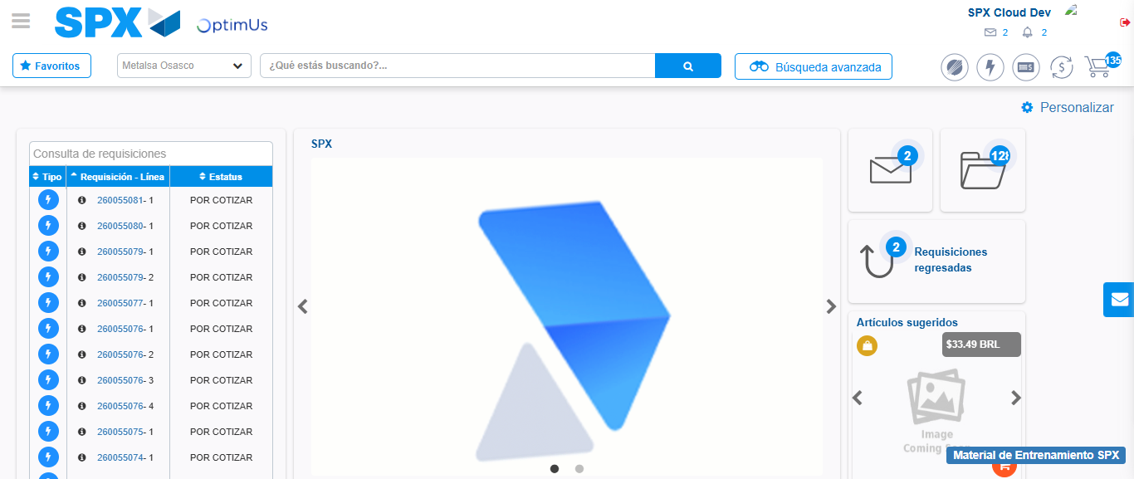Image file-name: QC_Testing-tc002_SPX_Dev5_Crear_Requisicion_Spot_Con_FAD_Tipo_Cobro_CC-1789483523924

